**Step 1: Set Up Your Redshift Cluster**

If you don't have a Redshift cluster set up already, you’ll need to:

1. **Create a Redshift Cluster**: You can use the AWS Management Console to launch a Redshift cluster.
2. **Set up a Security Group**: Make sure the Redshift cluster is accessible from your IP address (you may need to modify the Security Group settings to allow inbound access on port 5439).
3. **Set up IAM Role for S3 Access**: Attach an IAM role with permissions to access S3 if you're loading data from there.
4. **Create Redshift Database and Tables**: Once the cluster is ready, create a database and tables in Redshift.

**Step 2: Load Data into Redshift**

You can load data into Redshift using several methods, but one of the most common approaches is using **Amazon S3** and the **COPY command** in Redshift.

**Loading Data from S3 to Redshift**

Let’s assume you have a CSV file stored in an S3 bucket and want to load that data into Redshift. The process involves:

1. **Preparing the Data File**: Ensure your data is stored in a format Redshift can read (CSV, TSV, Parquet, etc.)

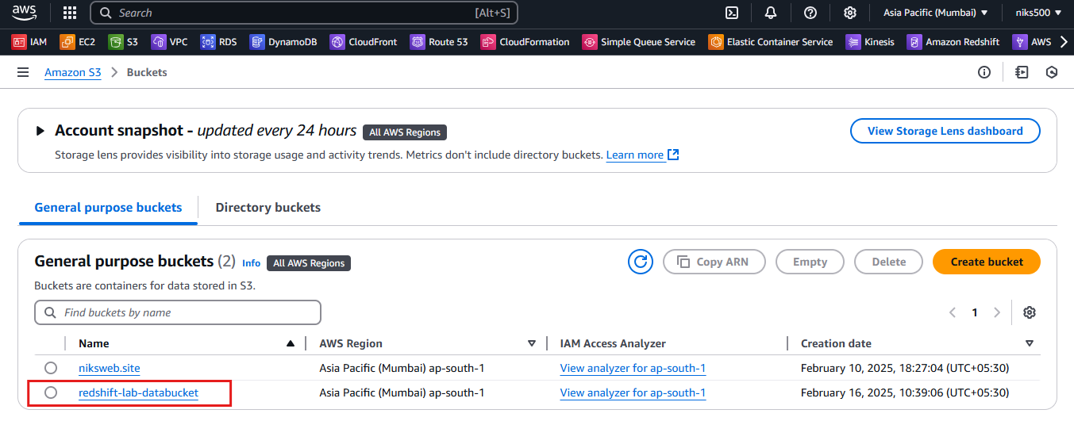

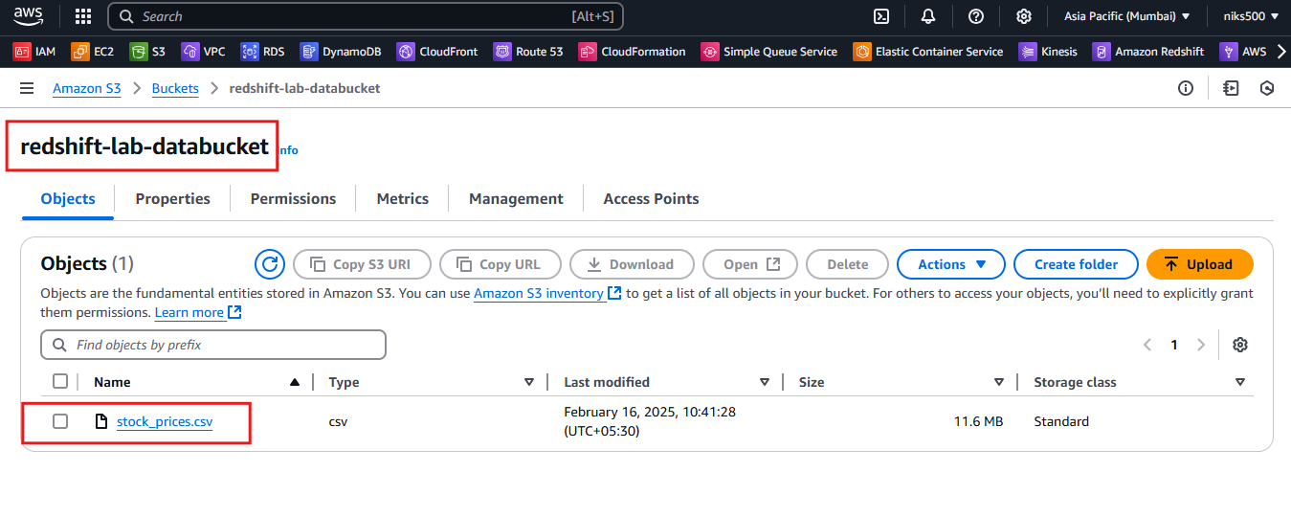

1. **Grant Permissions to S3**: Your Redshift cluster should have permission to access the S3 bucket (through an IAM role).

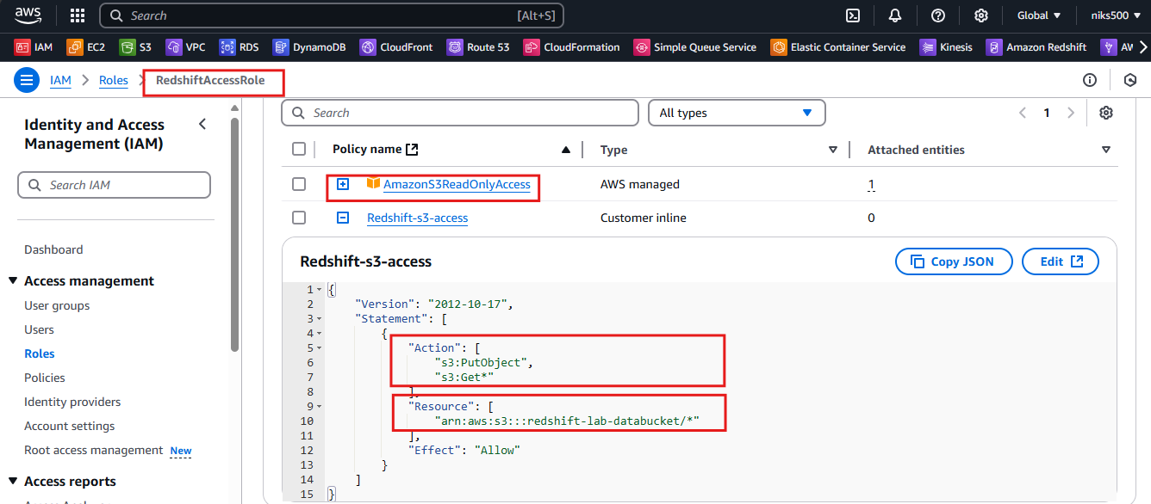

**Step 3: Create an external table**

1. Using the prompt, enter the following query to create an external schema named **spectrum**:

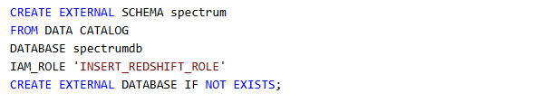

* Replace the **INSERT_REDSHIFT_ROLE** placeholder value with the **RedshiftRole** value listed to the left of these instructions. (Be sure to keep the single quote marks.)

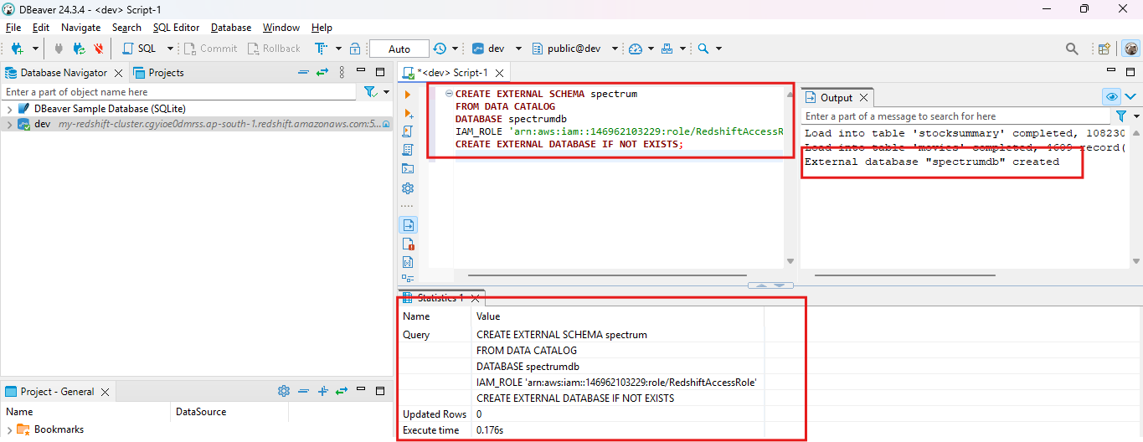

1. Using the prompt, enter the following query to create an external table with the **spectrum** schema named **stocksummary**:

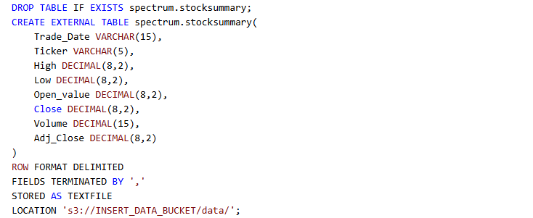

* Replace the **INSERT_DATA_BUCKET** placeholder value with the **DataBucket** value listed to the left of these instructions. (Be sure to keep the single quote marks.)

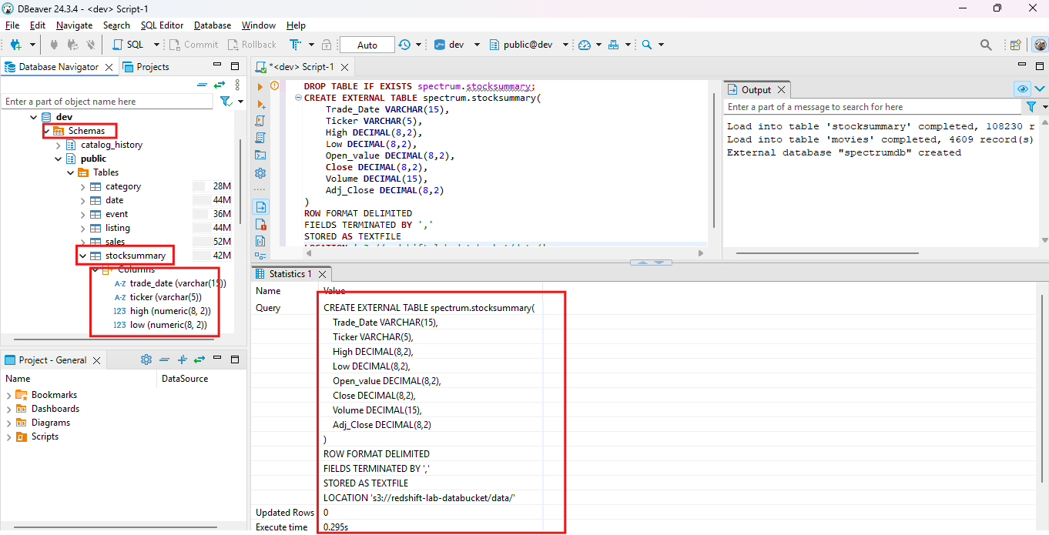

**Step 4: Query the data**

1. Query the external table to verify that the data imported correctly.
2. Using the prompt, enter the following query to display stock information from January 3, 2020:

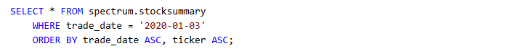

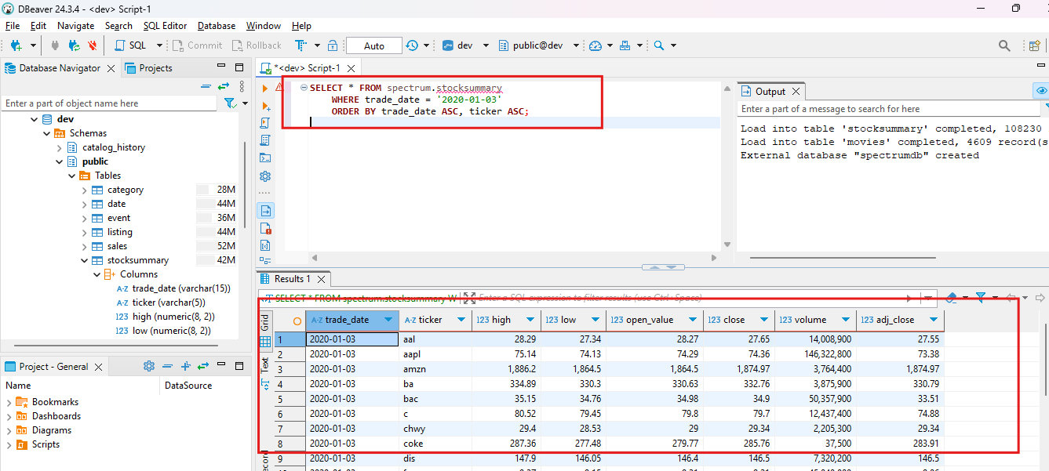

**Step 5: Create Materialized view**

1. Using the prompt, enter the following query to create a materialized view named **stocks_mv** that includes only the **trade_date**, **ticker**, and **volume** columns:



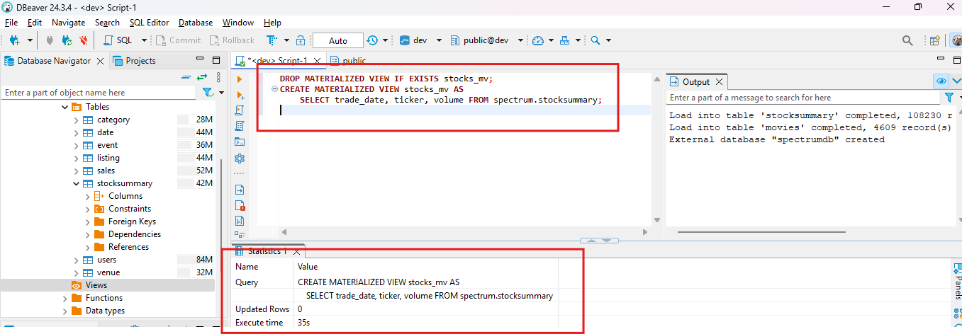

1. Using the prompt, enter the following query to display stock information in the materialized view from January 3, 2020:

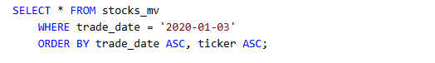

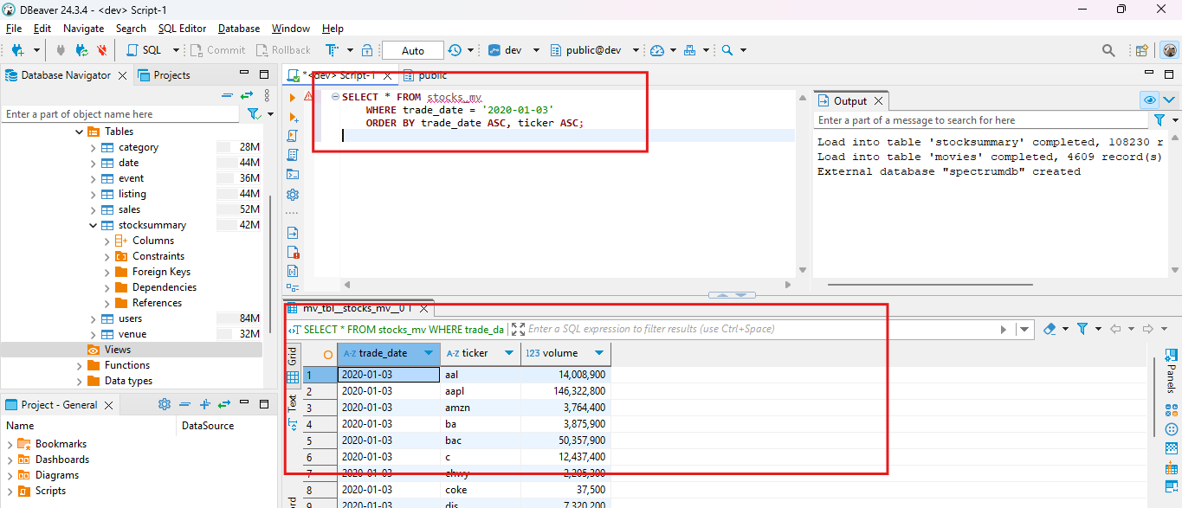

1. Enter the following query to display the top three stocks by volume from February 10th, 2020 to February 16th, 2020:

